

Fof量化投资交易管理系统

**Quantitative Investment Transaction**

**Management System of FOF**

**原型化迭代文档**



**Prototype Iterations Document**

——2016届“花旗杯”金融创新应用大赛

Contents

1. Prototype Overview 3

2. Prototype for Clients of PC on Windows 3

2.1 Interface flow chart of clients interface 3

2.2 Login and sign up interface 4

2.3 FOF management 5

2.3.1 Build FOF 5

2.3.2 Real-time monitoring 8

2.3.3 Profit and loss analysis 8

2.3.4 Performance attribution 9

2.3.5 Report statistics 9

2.3.6 Asset allocation 10

2.3.7 Position alteration records 10

2.3.8 Performance estimation 11

2.3.9 Adjust position 11

2.4 Market data 12

2.4.1 Market of fund 12

2.4.2 Details of fund 13

2.5 Warning controlling 13

2.6 Parameter adjustment 14

3. Prototype for Administrators of PC on windAows 14

3.1 Login and sign up 15

3.2 Accounts management 15

3.3 System logs 16

1. Prototype Overview

Prototype is a system, which refers to the original model of a product. In software development, it is an early version that can be run, which reflects the important characteristics of the final system. Before developing formal system, build the structure of a rapid prototyping system, to achieve interact with the system for customers or potential users, and further refines to meet the demands for the development of the software. By gradually adjust the prototype to satisfy customer requirements, developers can determine the real needs of customers, and thus develop software products to ultimate customer satisfaction.

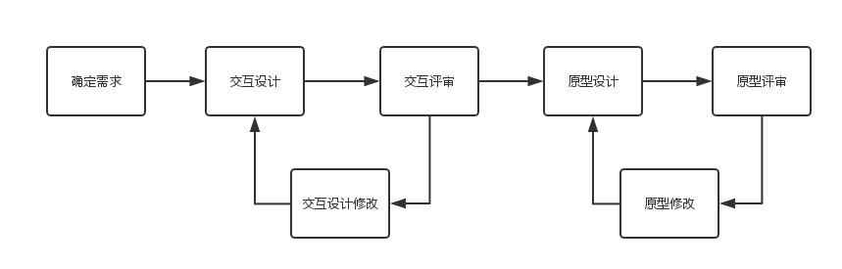This is a task in need of looped iteration, constantly revise. We get all the prototyping process as follows:

We use sketch on mac to make the prototype for the project, which direct thte development of our system.

# Prototype for Clients of PC on Windows

## Interface flow chart of clients interface

## Login and sign up interface



## FOF management

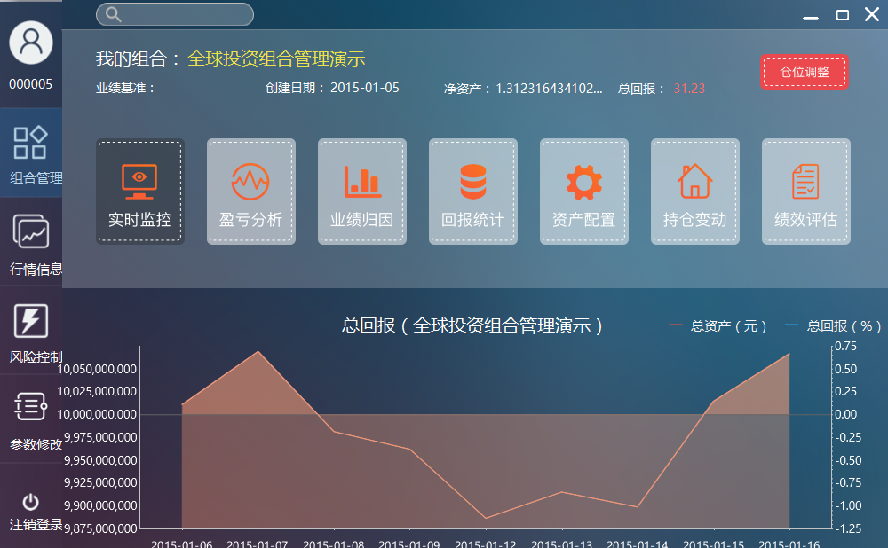

### Build FOF

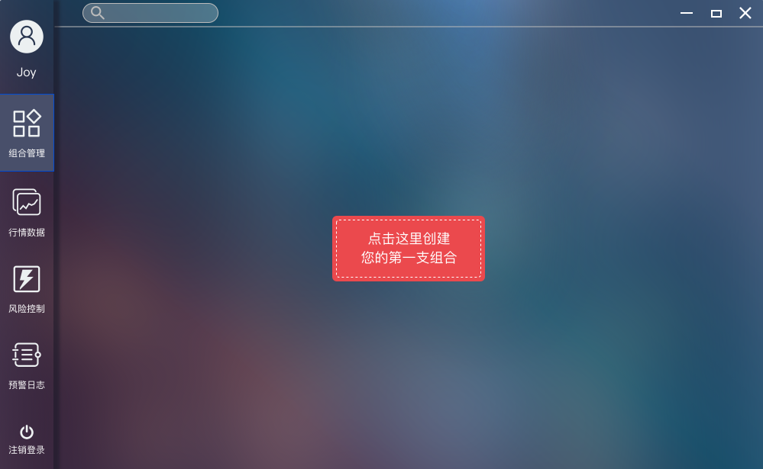

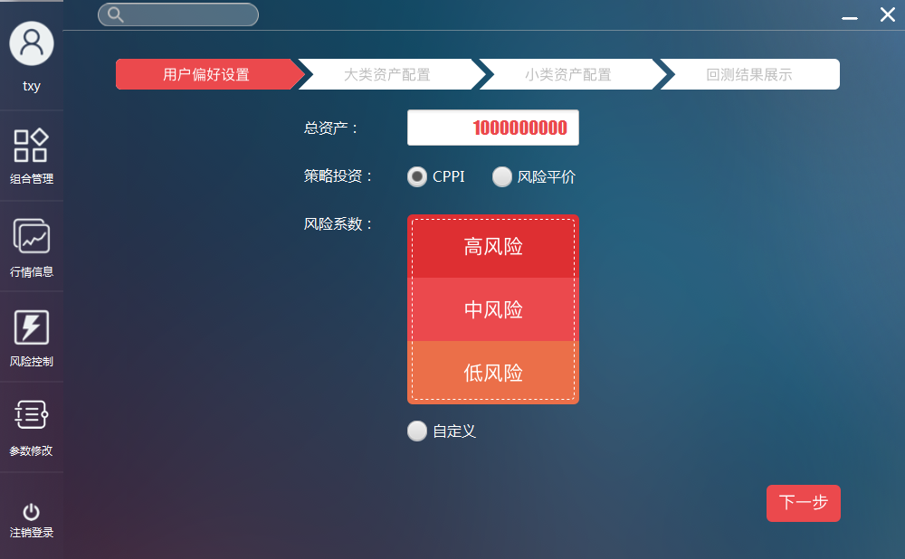

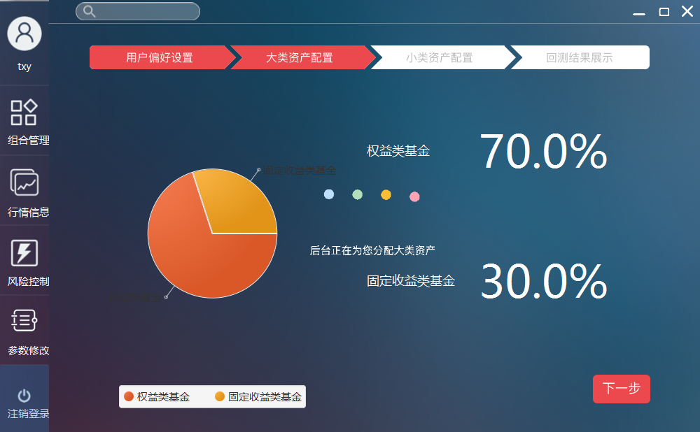

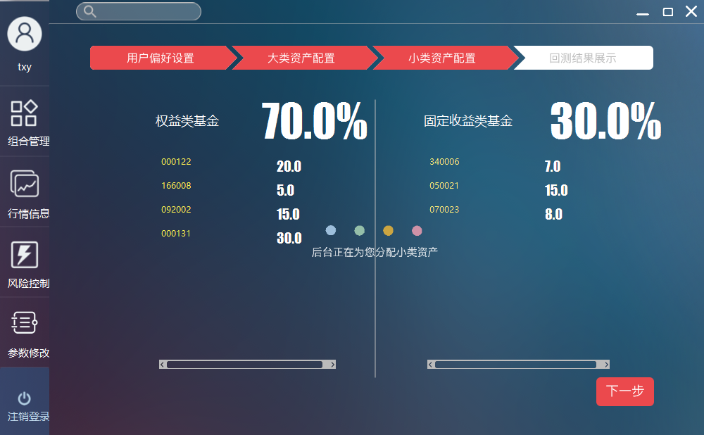

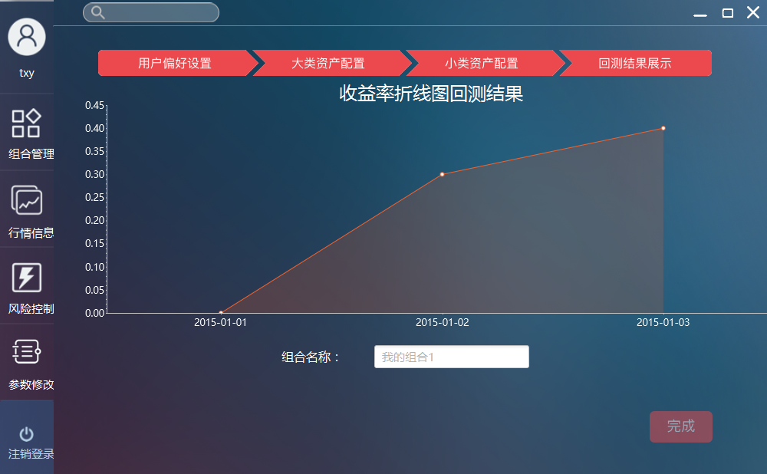

### Real-time monitoring

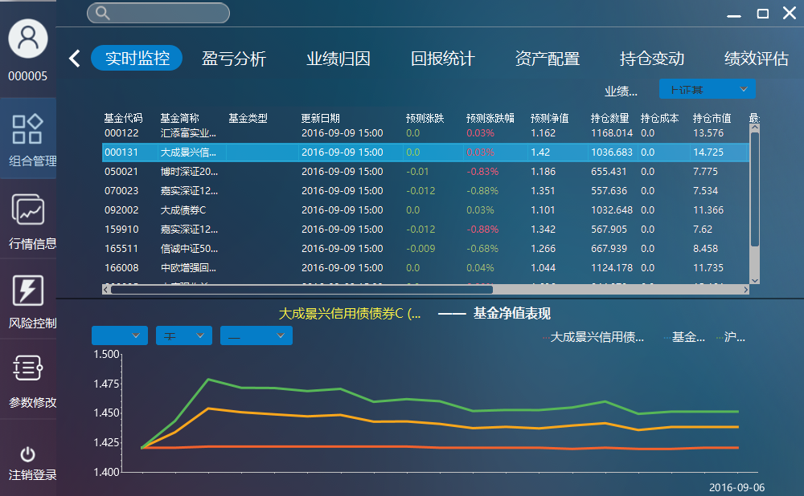

### Profit and loss analysis

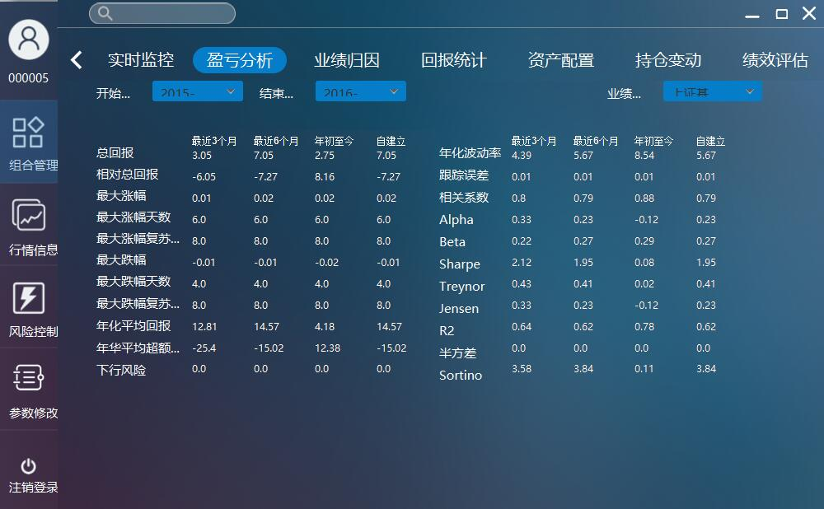

### Performance attribution

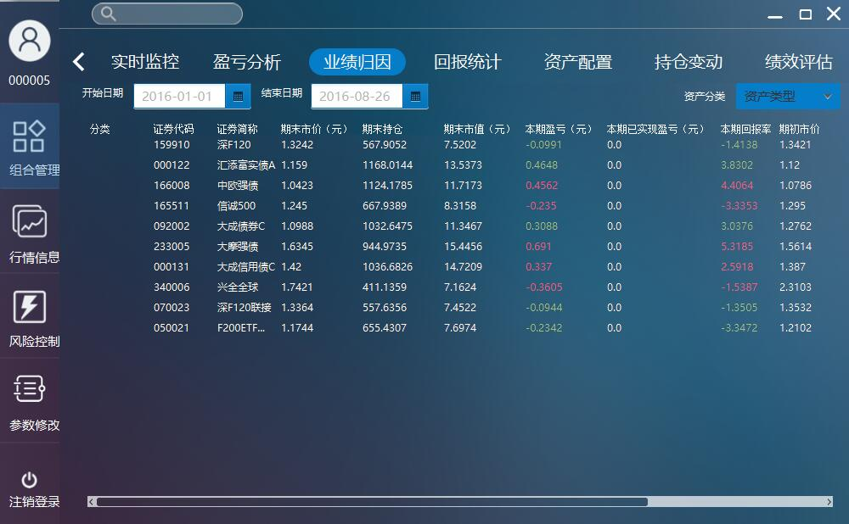

### Report statistics

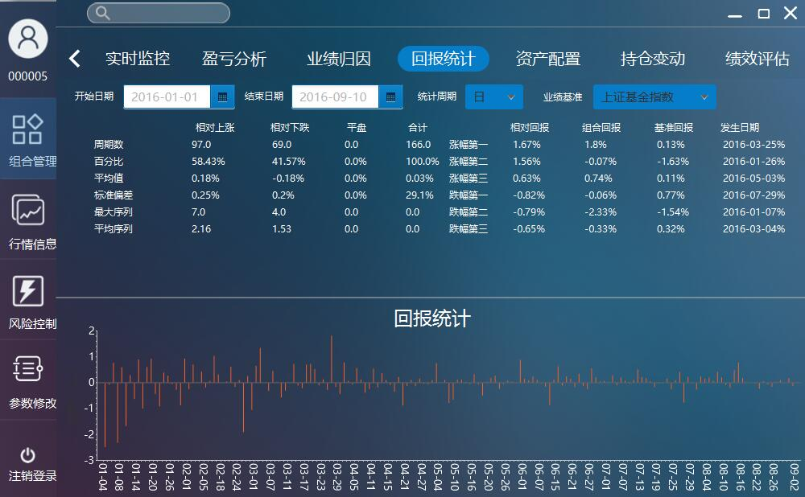

### Asset allocation

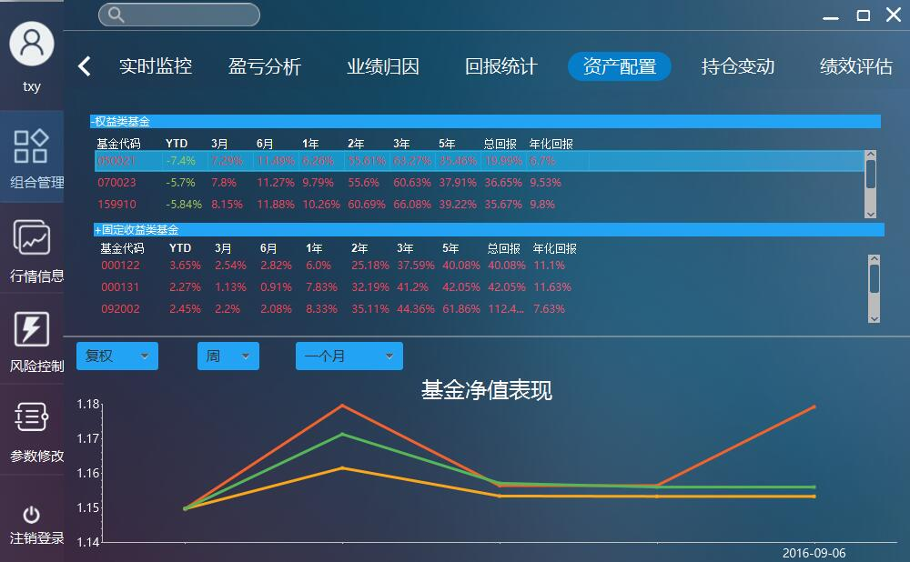

### Position alteration records

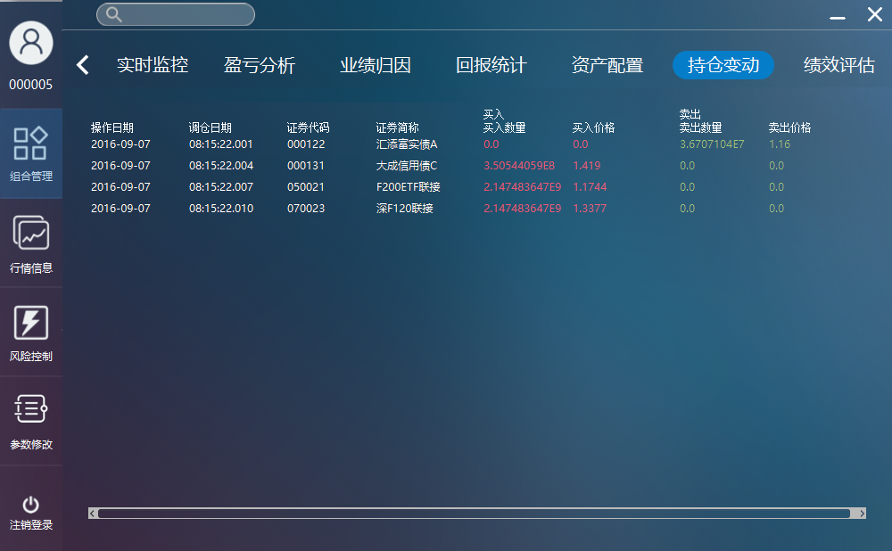

### Performance estimation

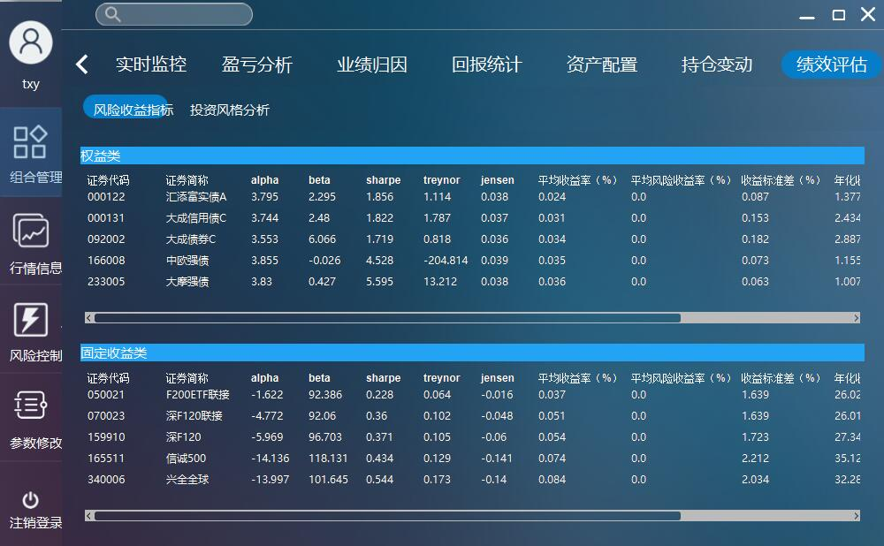

### Adjust position

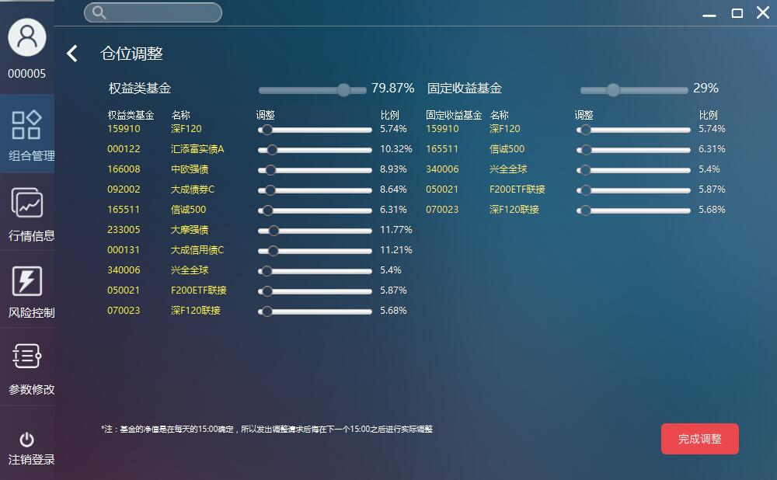

## Market data

### Market of fund

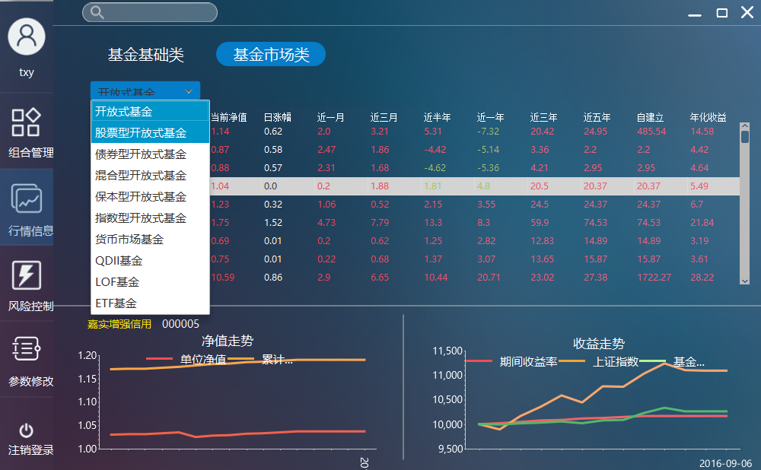

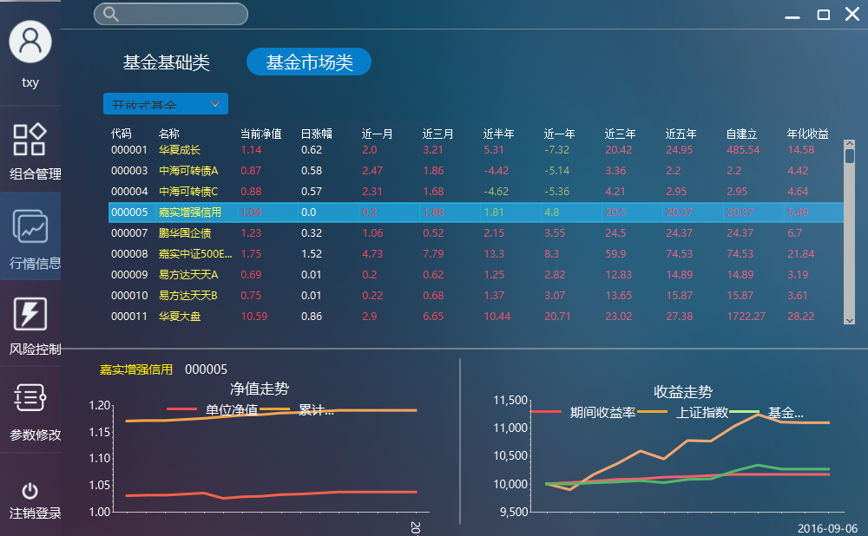

### Details of fund

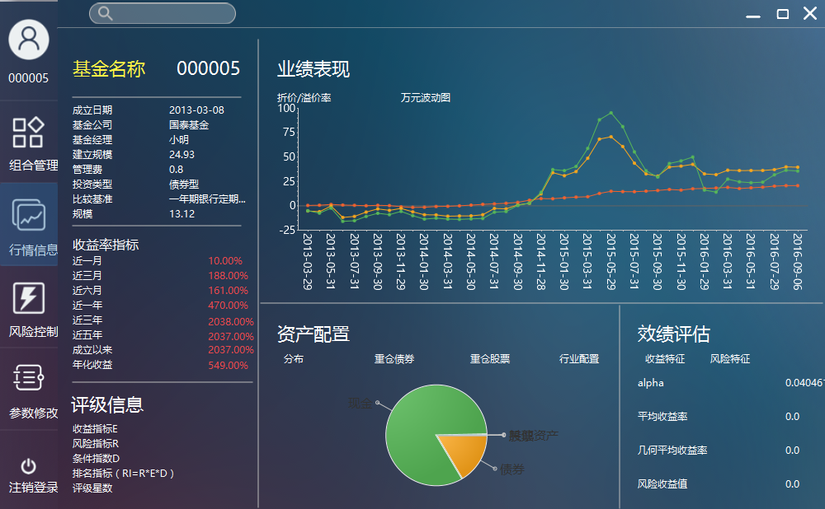

## Warning controlling

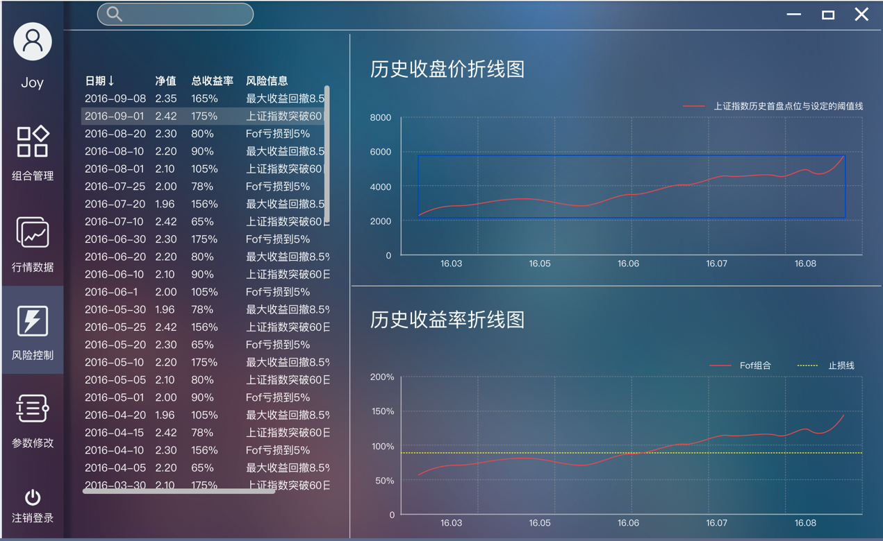

## Parameter adjustment

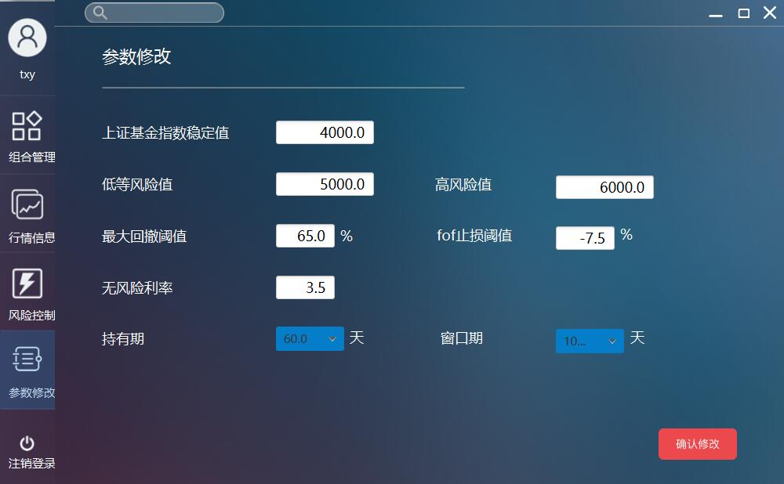

# Prototype for Administrators of PC on windAows



## Login and sign up



## Accounts management

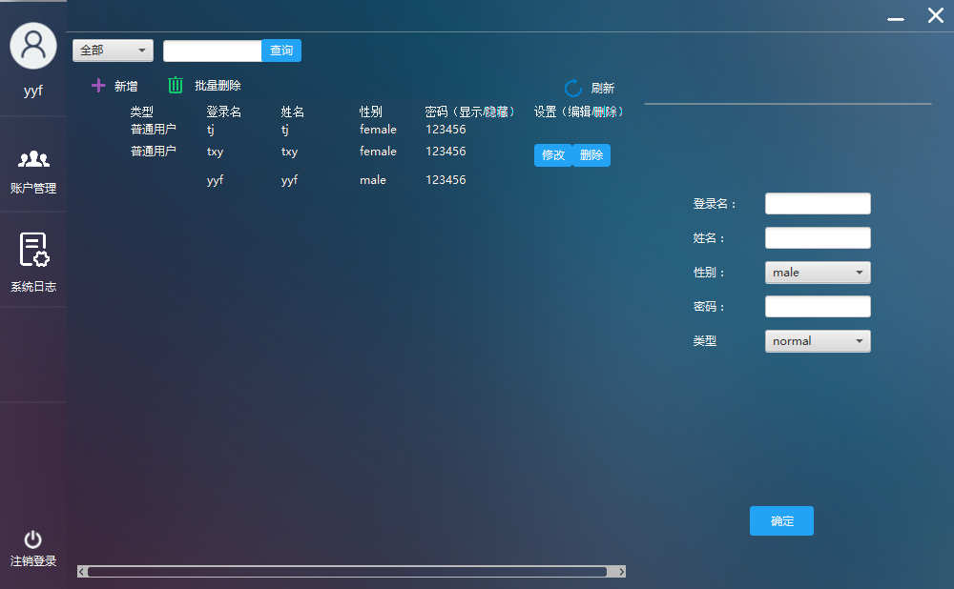

## ../../../../Desktop/系统日志.pngSystem logs